1. Double click on “**sqldeveloper.exe**” within SQL Developer folder to start the application.
2. Press “Ctrl + N” for adding new connection.

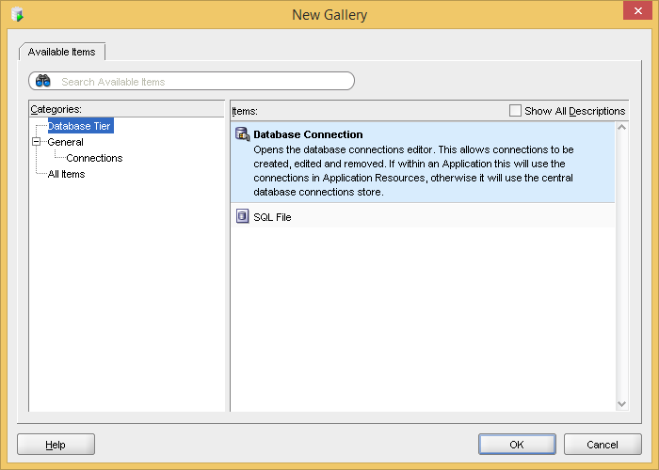

1. Click “OK”

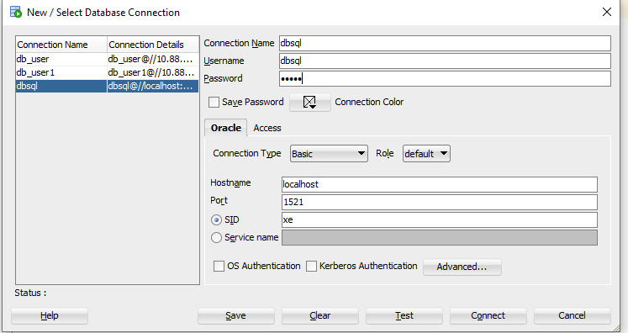

1. Enter Connection Name (of your own choice)
2. Enter Username, Password (User which you have created)
3. Click on Save Password,
4. Enter the Hostname as ‘localhost’ or IP address of machine on which oracle server is installed.
5. In case of enterprise edition use SID as ‘orcl’, in case of Express edition use SID as ‘XE’
6. Click “Test”
7. It should show status as “Success”.
8. Click on “Save”
9. Click on “Connect”.
10. Start writing your SQL Queries.